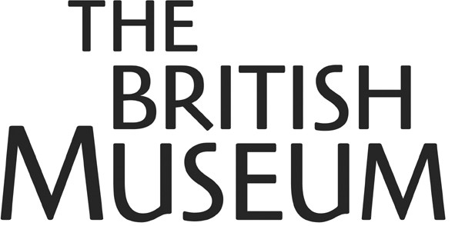

Request for the Repatriation of Human Remains to Tasmania

In accordance with our policy on Human Remains, we are publishing the dossier relating to the above claim received from Tasmania. Please note that it includes a list of correspondence, but not the correspondence itself. This is because we do not have permission from the authors of the letters to publish them.

If anyone wishes to make any comment, could they please write, by 20th March to:

Andrew Burnett
Deputy Director
The British Museum
Great Russell Street
London
WC1B 3DG

Or email: directorate@thebritishmuseum.ac.uk

